PROJECT OUTLINE
Bachelor of Engineering Honours in Robotics and Artificial Intelligence

Name
Kaung Linn Aung

Supervisor
Wong Kim Siong

Autonomous Underwater Robot (AUV) for Submerged Environment Scanning and Video Recording
Date - 31 July 2026
Table of Contents
1. Introduction 1
1.1 Project justification (what and why) 1
Literature review 1
Motivation 1
1.2 Project aims and objectives 1
1.3 Methodology (how) 2
System architecture 3
Hardware block diagram 3
Software block diagram 3
3D CAD Prototype Model 4
Real World Visualization Model 4
2. Resource analysis 5
Key resources required 5
Hardware: 5
Software: 6
Other Parts: 6
Facilities: 6
Key risk flagged for supervisor review 6
3. Project plan 7
Project work description 7
4. References / bibliography 8
Appendix A: Gantt chart (10-week schedule) 9
Appendix B: Project resources checklist 10
Appendix C: Project risk, ethics and threat assessment checklist 11
Appendix D: Industrial projects 12

1. Introduction

1.1 Project justification (what and why)
Underwater structural inspection (e.g. of test tanks, pipework and small marine assets) is normally carried out by divers or by using commercial remotely operated vehicles (ROVs) which cost thousands of pounds and are unsuitable for small-scale or educational use. This project involves building an active buoyancy ballasted autonomous underwater vehicle (AUV) equipped with vectored thruster propulsion and onboard computer vision which will autonomously survey a submerged test-tank environment and identify visual anomalies, at a target cost significantly less than commercial AUVs.

Literature review
Four related projects and research areas were examined to identify design gaps this project will fill:
- ESP-DIVE (Instructables) by Max Imagination — an FPV RC submarine with a low cost active buoyancy ballast system using medical syringes and N20 micro-geared motors, with inductive charging to keep the hull permanently sealed. Gap: A single microcontroller without any built-in vision, or autonomous logic. [1]
- BlueROV2 (commercial baseline) — an industry standard multi-axis ROV with independent ESCs for each brushless thruster for structural agility. Gap: the commercially priced components are not within the budget of this project, but the per-thruster ESC architecture is used here. [2]
- HippoCampus AUV (Technical University of Hamburg) — a micro-AUV for test-tank applications using 3D printed structural components and an equipment sled inside the AUV. Gap: verified that PETG 3D printing is a viable option for a university-lab budget and used for the end-caps and sled of this project. [3]
- Academic research on edge-AI marine inspection systems — shows that lightweight computer-vision models (OpenCV, TensorFlow Lite) can be deployed on the low-power single-board computers to enable real-time subsurface object/anomaly detection. [4]
The gap this project fills is the combination of the low-cost ballast/hull approach of ESP-DIVE, the 3D-printed construction of HippoCampus and an onboard edge-AI vision pipeline and closed-loop autonomous control; none of the reviewed projects combine all three at low cost.

Motivation
There are three factors that converge to motivate this project. First, the cost of the AUVs are still too high for educational institutions and hobbyist research (most commercial systems (untethered or tethered BlueROV2, BlueROV1, professional AUVs) cost SGD 5,000-50,000+ and are not accessible to students and small labs. A cost optimized platform (SGD 400-600 in parts) would enable hands-on experience with underwater autonomy, marine robotics and embedded control systems to be made available to everyone. Second, making the AUV in university size has real engineering depth: using dual processor heterogeneous control (Pi for high level vision, STM32 for real time motor control), designing a pressure vessel that seals under load, implementing software failsafes for underwater operation, and debugging underwater failures is much more complicated than a land based robot. Third, the challenge of getting a full autonomous system into a sealed tube, 110mm x 500mm, with a processor, sensors, an active ballast mechanism and a power budget, involves a series of design compromises and problem solving in the real world, which makes it a great capstone project for embedded systems and robotics engineering. The edge-AI component (on-device computer vision for target tracking) brings modern relevance to the autonomous decision making process in resource-constrained environments.

1.2 Project aims and objectives
Aim: To develop, construct and evaluate an autonomous underwater vehicle which can autonomously survey an underwater test-tank environment for visual anomalies, with a dual-processor control architecture, and which is low cost.
Objectives:
- Design and build a pressure rated, sealed hull (110mm diameter x 500mm length PVC) to house electronics equipment sled.
- Design and program a UART master/slave communication protocol between the Raspberry Pi 5 (master) and STM32 Nucleo-F411RE (slave), with a failsafe feature that will cause the slave to surface after 3 seconds of no communication.
- Create secondary-MCU firmware to produce PWM signals for 3 brushless ESCs and to poll the MPU-6050 IMU and MS5837-30BA pressure sensor via I2C with noise filtering.
- Develop a closed loop PID controller for depth and attitude control based on the fused sensor data.
- Active buoyancy ballast system (dual medical syringes with N20 geared motors) controlled from the navigation loop.
- Create an OpenCV computer-vision module on the Raspberry Pi 5 that will track a target and detect anomalies in the camera feed in real-time.
- Put in place a logging system for video and telemetry data onboard for post mission analysis.
- Test and validate the entire system in the test-tank environment to meet specified success criteria (stays within target depth range, completes a pre-programmed mission sequence, surfaces safely when communication is lost).

1.3 Methodology (how)
The project features a dual processor heterogeneous architecture: the Raspberry Pi 5 is used for high level autonomy (Python mission planner, OpenCV vision pipeline, telemetry logging) with moderate latency, and the STM32 Nucleo-F411RE is used for low level real-time control (C/C++ firmware for ESC PWM generation, I2C sensor polling, UART heartbeat failsafe) with hard timing guarantees, with communication between the two processors via serial UART. This separation means that if the Pi crashes, or the vision pipeline is delayed, the STM32 can still perform an emergency-surface on a 3 second watchdog. Development is based on a staged integration approach to bring high-risk items to the surface early
- finalize mechanical design and potting and testing of pressure hull under simulated load before full integration;
- bring up MCU-Pi UART communication and validate low level ESC/sensor control on bench in isolation;
- integrate IMU and pressure sensor with closed loop PID depth-hold;
- add vision pipeline and validate target detection in controlled lighting;
- perform full waterproofing (potting, sealant, O-ring validation) and leak test of assembled unit;
- tank trials for buoyancy tuning, thruster vectoring validation, and failsafe activation.
The critical path (hull sealing, dual-MCU communication) is validated first in this bottom-up approach, which helps to avoid waste in the final integration phase when vision and autonomous behaviors are debugged. Testing at each stage is a mixture of bench simulation (power supply, logic analyzer for PWM), isolated tank trials (sub-surface only, no full mission) and final closed-loop tank trials. The metrics include: hull leak rate (0 is acceptable), ESC response time (< 50ms), depth-hold error (< 0.2m), vision frame rate (≥ 10fps at 320×240), and failsafe activation latency (< 3.5s).

System architecture

Hardware block diagram
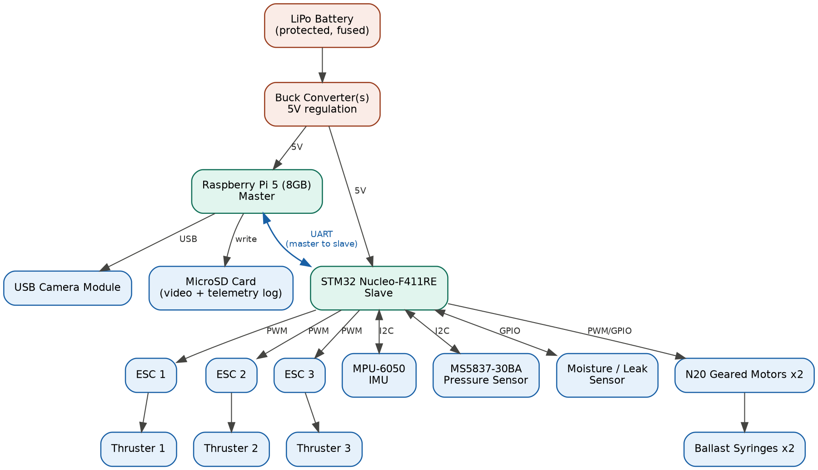
Figure 1 Hardware block diagram. LiPo battery power is regulated and split to the Raspberry Pi 5 (master) and STM32 Nucleo-F411RE (slave), linked over UART. The Pi 5 handles the camera and onboard storage; the STM32 drives the three ESC/thruster channels and the ballast motors, and polls the IMU, pressure and moisture sensors over I2C/GPIO.

Software block diagram
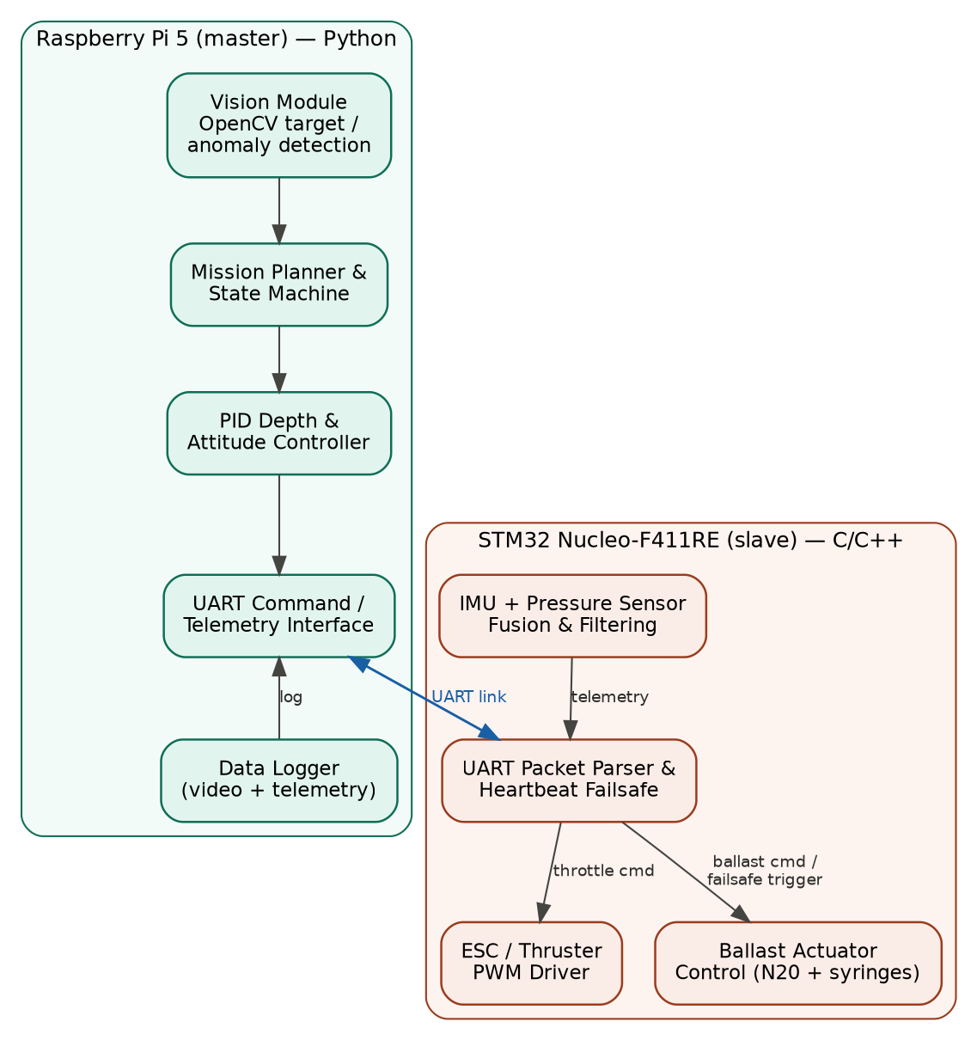
Figure 2 Software block diagram. On the Raspberry Pi 5, the vision module feeds the mission planner and PID controller, which sends commands over UART and logs telemetry. On the STM32, the UART parser drives the ESC/thruster PWM and ballast actuator modules and

3D CAD Prototype Model
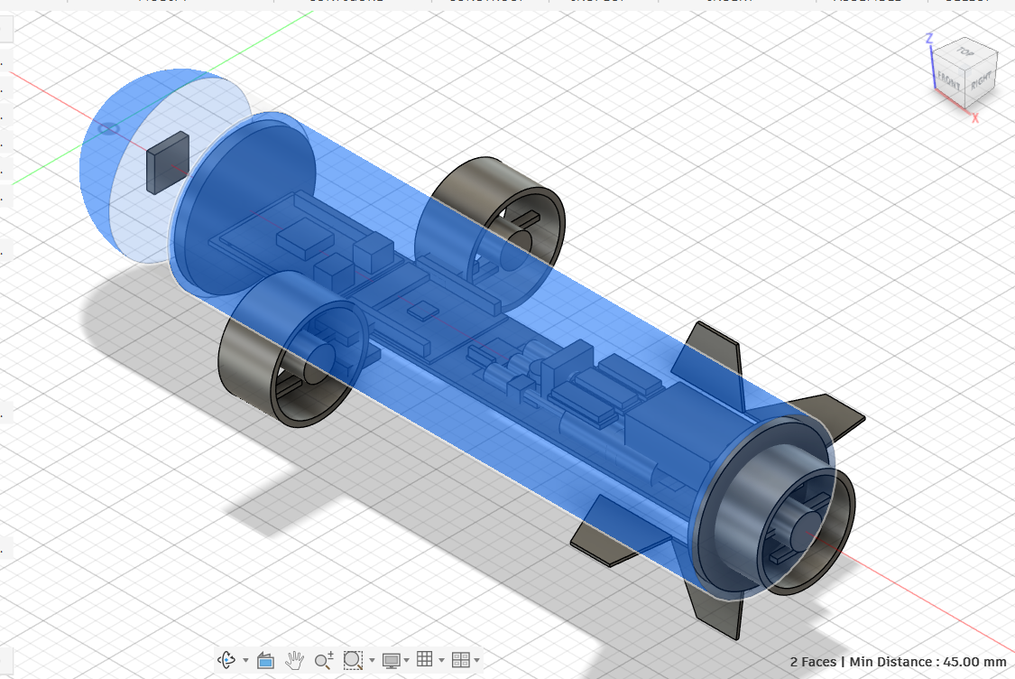
Figure 3 3D Fusion 360 model showing internal equipment sled layout and component placement inside 110mm × 500mm PVC pressure hull.

Real World Visualization Model

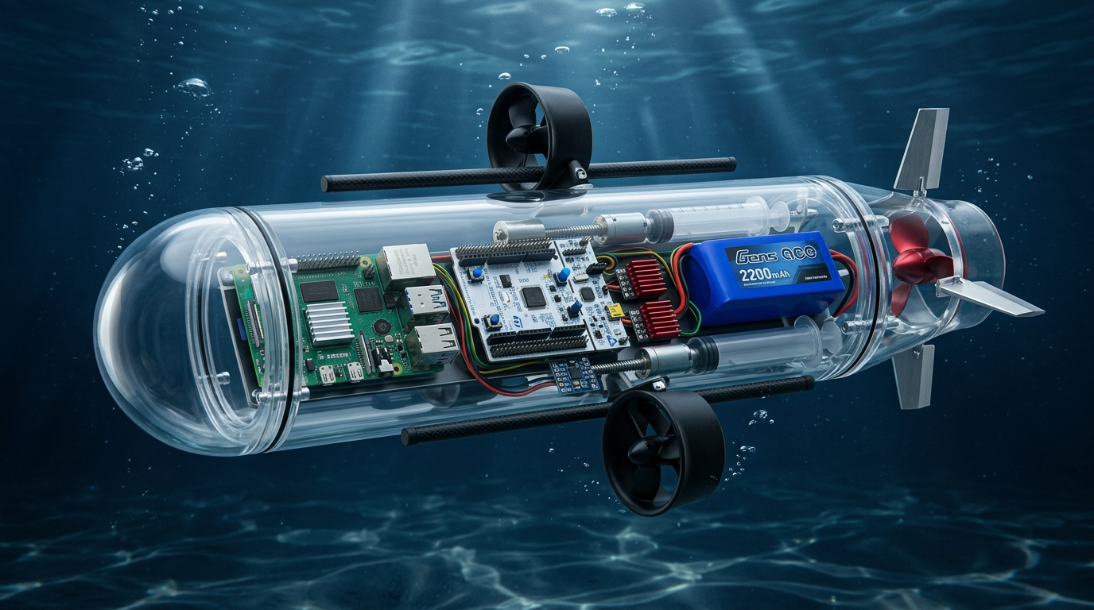
Figure 4 Real World Prototype Visualized

2. Resource analysis
This project requires specialized hardware components for underwater operation, embedded software for dual-processor control and autonomous decision-making, and university lab facilities for fabrication, assembly, and tank testing. The following sections detail the key resources organized by category, resource availability, and cost estimates.

Figure 5 Bill of Materials

Key resources required

Hardware:
- Raspberry Pi 5 (8GB) - main onboard computer
- STM32 Nucleo-F411RE - secondary MCU for thruster control
- MPU-6050 IMU - orientation/attitude sensing
- MS5837-30BA pressure sensor - depth measurement
- Moisture/leak sensor - water ingress detection
- 3× brushless motors (vectored thrusters) - propulsion
- 3× electronic speed controllers (ESCs) - motor drivers
- 2× N20 micro-geared motors - ballast actuation
- 110mm × 500mm PVC or 3D-printed hull - main pressure vessel
- PETG 3D-printed end-caps - hull closure
- Nitrile O-rings - hull seal compression
- USB camera module - video acquisition
- Protected LiPo battery (3S) - power source
- 5V/5A buck converter (Pi 5 dedicated rail)
- 5V/2A buck converter (sensors/ESCs rail)
- Cooling fan - thermal management
- Fuse link - power cutoff protection

Software:
- Fusion 360 - CAD design and 3D modeling
- Arduino IDE / STM32CubeIDE - embedded firmware development
- Python with OpenCV - computer vision pipeline
- Git/GitHub - version control and code repository
- MicroSD card (64GB) - onboard data logging

Other Parts:
- 2× medical syringes (10ml) - ballast plunger chambers
- Epoxy potting compound / marine sealant - waterproofing
- Jumper wires and connectors - internal wiring
- UART cable - Pi to MCU serial link
- LiPo balance charger - external charging
- Fire-resistant bag - battery storage/transport

Facilities:
- University Robotics & AI Lab - primary workspace and test tank
- Mechanical Lab - workshop tools and power tools
- 3D printer (in-lab) - PETG end-cap and component printing
- Fusion 360 academic license access

Estimated total component cost: approximately S$397 (shown in Figure 5), largely offset by items borrowed from university lab inventory.

Key risk flagged for supervisor review
The Raspberry Pi 5 is only officially rated at 5V/5A when it's used in full, and the power design is a single 5V/4A buck converter shared with the secondary MCU, sensors and cooling fan, which is too small. Recommendation: Divide into 2 regulator branches or upsize shared converter with margin prior to final build (see attached Risk Assessment and BOM (Figure 5) for details).

3. Project plan

Project work description
The table below summarises the work packages for the build/test phase, with estimated hours and the main risk to each objective. Full week-by-week scheduling is given in Appendix A.
Task | Hours | Weeks | Key risk
CAD finalisation & hull fabrication | 20 | 1-2 | Fusion 360 licence delay; printer availability
Secondary MCU firmware: UART link + failsafe | 15 | 2-3 | Packet framing / timing bugs
ESC/thruster PWM integration & bench test | 15 | 3-4 | ESC calibration; current draw
IMU + pressure sensor I2C integration | 12 | 3-4 | MS5837 I2C reliability on MCU
Ballast system integration (N20 + syringes) | 15 | 4-5 | Seal leakage; ballast travel
Power system rebuild (dual rail, fuse, moisture sensor) | 10 | 5 | Regulator undersized (flagged above)
Vision module (OpenCV) on Raspberry Pi 5 | 20 | 5-7 | Real-time performance
PID depth/attitude control tuning | 15 | 6-7 | Control loop instability
Waterproofing & leak testing | 15 | 7-8 | Hull seal failure — highest overall risk
Full system integration & bench test | 10 | 8 | Integration bugs across subsystems
Tank testing & mission validation | 15 | 9 | Unexpected underwater behaviour
Data evaluation & report preparation | 10 | 10 | Time overrun

4. References / bibliography
- Max Imagination — ESP-DIVE. Instructables. https://www.instructables.com/ESP-DIVE-Build-an-ESP32-RC-Submarine-With-FPV-Came/
- Blue Robotics — BlueROV2. https://bluerobotics.com/store/rov/bluerov2/
- Technical University of Hamburg — HippoCampus AUV project. https://hippocampusrobotics.github.io/
- Academic literature on edge-AI marine inspection frameworks using OpenCV/TensorFlow Lite on single-board computers.
- STMicroelectronics. STM32F411xC/xE Datasheet (DS10314). https://www.st.com/resource/en/datasheet/stm32f411re.pdf
- Zephyr Project Documentation. Nucleo F411RE Board. https://docs.zephyrproject.org/latest/boards/st/nucleo_f411re/doc/index.html
- RIOT OS Documentation. STM32 Nucleo-F411RE. https://riot-os.readthedocs.io/generated/group/group__boards__nucleo-f411re.html
- DeepBlueMbedded. STM32 Low Power Modes (Ultimate Guide). https://deepbluembedded.com/stm32-low-power-modes-ultimate-guide/
- Blue Robotics. BlueRobotics_MS5837_Library (GitHub). https://github.com/bluerobotics/BlueRobotics_MS5837_Library

Appendix A: Gantt chart (10-week schedule)
Task | W1 | W2 | W3 | W4 | W5 | W6 | W7 | W8 | W9 | W10
Hull fabrication
MCU firmware + failsafe
ESC/thruster integration
Sensor (IMU/pressure) integration
Ballast integration
Power rebuild
Vision module
PID tuning
Waterproofing & leak test
System integration
Tank testing
Evaluation & report prep

Appendix B: Project resources checklist
Student’s Name: | Kaung Linn Aung
UH Student ID Num: | 24123115
Project Title: | Development of a Low-Cost Autonomous Underwater Vehicle (AUV) with Edge-AI Vision for Subsurface Inspection
Supervisor’s Name: | Wong Kim Siong
Date: | 31 July 2026

# | Question | Answer | Details
1 | Will materials or components need to be ordered? | Yes | See attached Bill of Materials — mainly Shopee.sg / Cytron / HobbyKing items
2 | Will you be designing a PCB requiring manufacture? | No | —
3 | Will pre-manufactured School PCB/drawing assemblies be required? | No | —
4 | Will a PC be required for work other than report writing? | Yes | CAD, firmware development, vision pipeline development
5 | Special hardware installed/attached? | No | Standard USB/ST-LINK programming only
6 | Specific software required? | Yes | Fusion 360, Arduino IDE / STM32CubeIDE, Python + OpenCV, Git
7 | Will technical staff / workshop facilities be required? | Yes | 3D printing, PVC cutting/drilling
8 | Which workshop activities (if Q7 yes)? | — | 3D printing, drilling, general fabrication
9 | Other resources required? | No | —

Appendix C: Project risk, ethics and threat assessment checklist
# | Question | Answer | Details
1 | Voltages above 30V / high current at low voltage / rotating machines / high-low temp / hazardous fluids or gases / radiation / hazardous chemicals? | Yes | High current at low voltage (LiPo battery); rotating machines (thrusters, N20 motors); chemicals hazardous to health (epoxy potting/marine sealant) — all detailed in attached Risk Assessment Form
2 | Electrodes attached to a person for low-impedance contact? | No | —
3 | If Q1/Q2 yes, has a risk assessment been carried out? | Yes | Completed — see attached Risk Assessment Form
4 | Does the risk assessment show an acceptable level of risk? | Yes | With additional controls listed in the Risk Assessment Form
5 | Hazardous-to-health substances used? | Yes | Epoxy potting compound / marine sealant — see Risk Assessment Form
6 | Flammable substances used? | No | LiPo fire risk is an electrical/thermal hazard, addressed under Q1 and in the Risk Assessment Form, not a flammable-substance-in-use case
7 | Other aspects posing danger to self or others? | Yes | Combination of electronics and water during tank testing — see Risk Assessment Form
8 | Will the work involve human subjects (survey, interview, experiment, incl. friends/family)? | No | —
Since Q8 is No and Q2 is No, submission to the Ethics Committee is not required. Since Q1 is Yes, the completed Risk Assessment Form (attached separately) must be approved and signed by the supervisor and lab engineer prior to submission, per the note in this checklist.
This project does not involve animal experimentation or testing.

Appendix D: Industrial projects
Not applicable — this is not an industrially based project.

